Flask To-Do App - Git & GitHub Assignment Submission

Student Name: Anirudh
GitHub Repository: https://github.com/anirudh201/flask-todo-app

Section 1 – GitHub Repository & SSH Setup

1. A new GitHub repository named "flask-todo-app" was created.
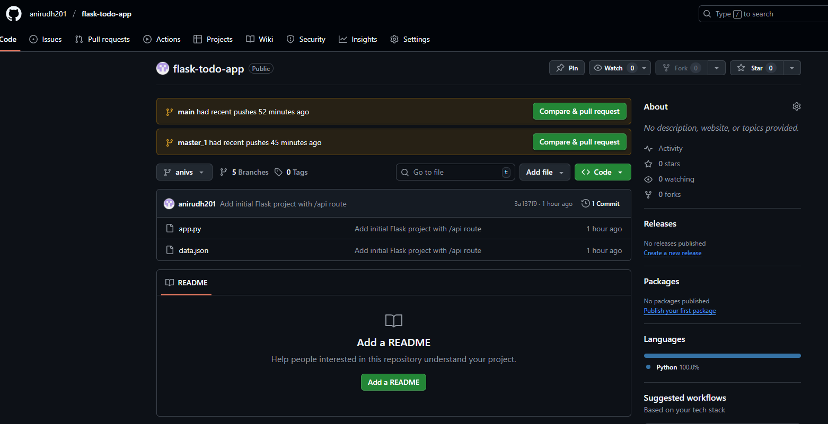
2. SSH key was generated using:
ssh-keygen -t ed25519 -C "email"
3. Public key was added to GitHub under SSH setting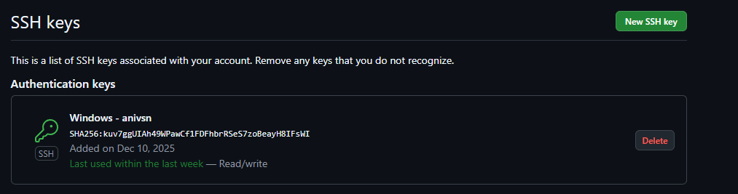gs.
4. SSH authentication was tested using:
ssh -T git@github.com

5. Repository was cloned using:
git clone git@github.com:anirudh201/flask-todo-app.git
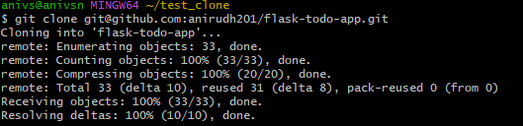

Section 2 – Username Branch and Initial Flask Project

1. A new branch named "anivs" was created.
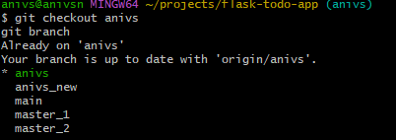
2. Flask project with app.py and data.json was added.
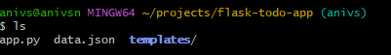
3. Changes were committed and pushed.
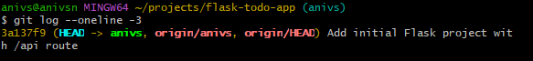
4. The branch was merged into main.
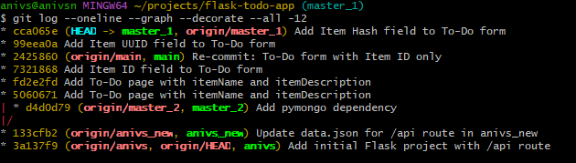

Section 3 – anivs_new Branch and JSON Update

1. A new branch named "anivs_new" was created from main.
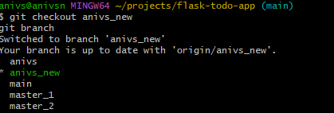
2. The data.json file was updated.
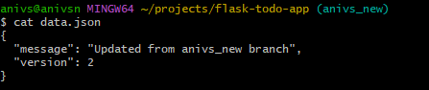
3. Changes were committed and merged into main.
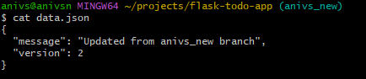
4. Conflicts were resolved by accepting anivs_new changes.
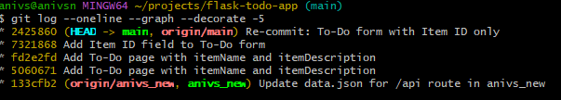

Section 4 – master_1 and master_2 Branches
1. master_1 branch was used for frontend To-Do form.
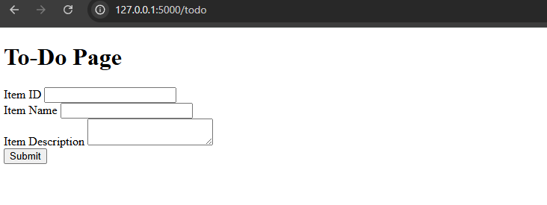

2. master_2 branch was used for backend /submittodoitem API.
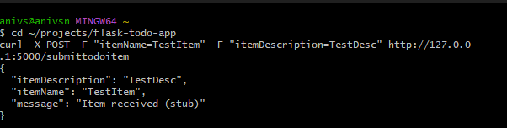
3. Both branches were merged into main.
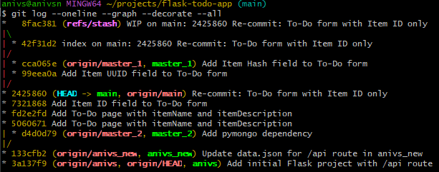

Section 5 – To-Do Fields, Reset and Rebase

1. Three commits were created in master_1:
- Add Item ID
- Add Item UUID
- Add Item Hash
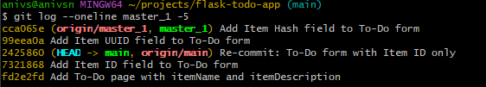

2. master_1 was merged into main
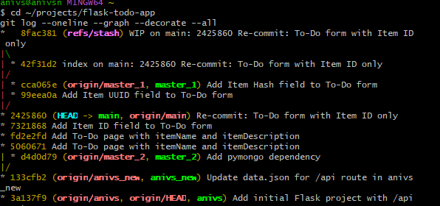.
3. main was reset using:
git reset --soft <item_id_commit>
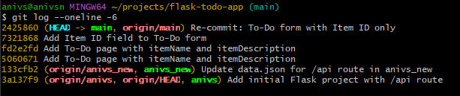
4. Only Item ID was re-committed.
5. master_1 was rebased onto updated main.

Section 6 – Final Verification
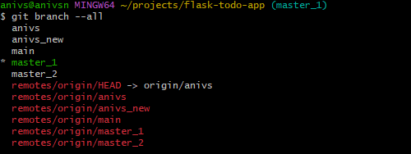


Final verification was done using:
git branch --all
git log --oneline --graph --decorate --all

